Monster Genetics Project

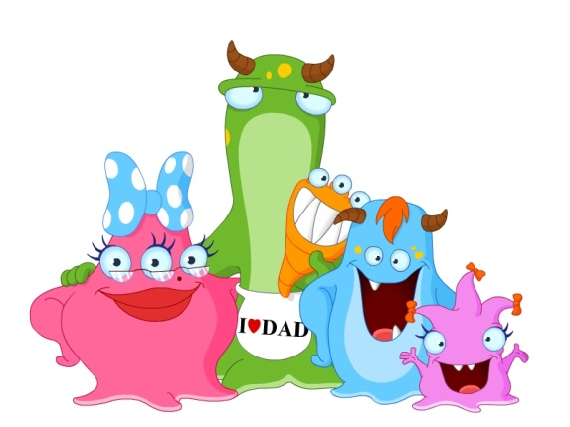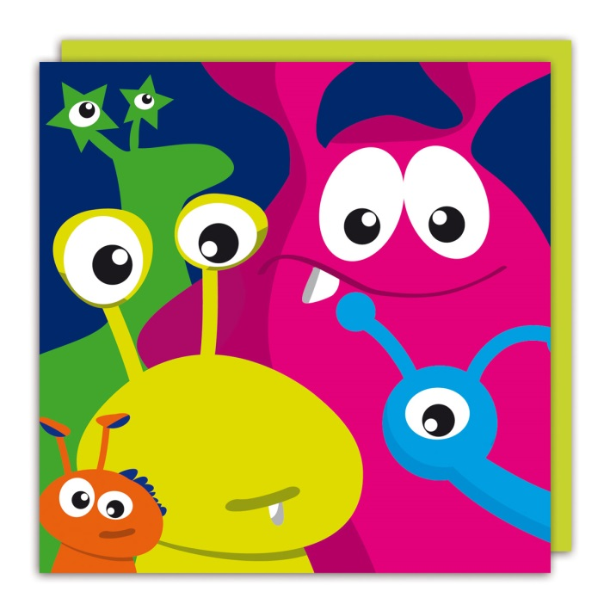

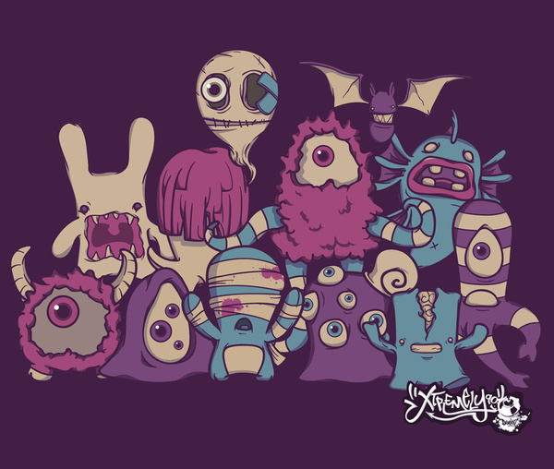

Project Description: You (or you and 2 partners) are to create a poster of a Monster Family using Mendelian Genetics.
- Randomly determine the traits for a Female and Male Monster
- Have a Monster Marriage, and then make a Monster Baby using the traits from Mom and Dad Monster.
- Draw the Monster family on a poster to present to the class.

Monster Genetics Project Procedures
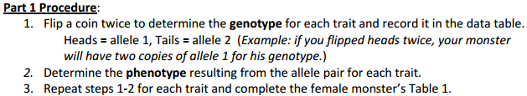

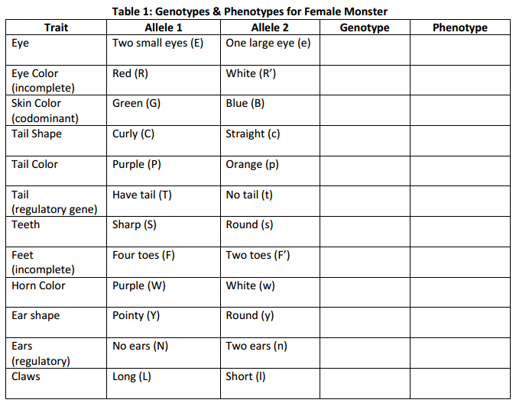

In Table 1.1, come up with 5 more original traits for your female monster. Refer to Table 1 for examples. Be Creative!!!!!!!
Table 1.1 Additional Genotypes and Phenotypes for Female Monster
Trait | Allele 1 | Allele 2 | Genotype | Phenotype

Part 2 Procedure:
- 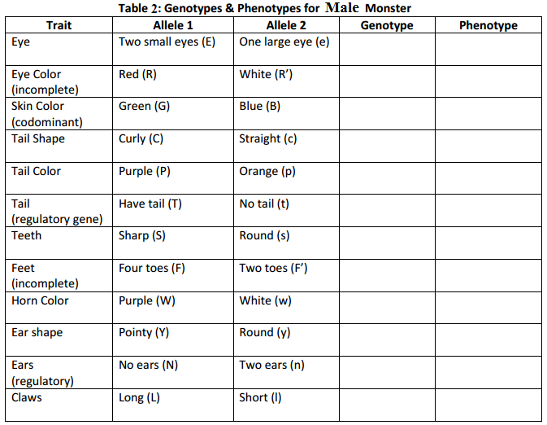Complete the male monster trait tables below (2 and 2.1) in the same way that you used for the female monster trait tables.
In table 2.1 below, fill in the table with the same traits that you created for your female monster in table 1.1.
Table 2.1 Additional Genotypes and Phenotypes for Male Monster
Trait | Allele 1 | Allele 2 | Genotype | Phenotype

Part 3 Procedure:
- Fill out the tables below with the Female’s and the Male’s Genotypes and Phenotypes.
- These Tables are to be cut out and attached to your poster.

Table 3: Female Traits Table 4: Male Traits
Genotype | Phenotype
Genotype | Phenotype

Part 4 Procedure: Punnett Squares
- Monohybrid Crosses: You are to create a Monohybrid Cross Punnett square for every trait of your Monsters. There are 17 total traits, so you will have 17 Monohybrid Punnett squares. Be sure to label each Punnett Square. Along with each Punnett square, there should be a Genotype/Phenotype ratio with percentages. See example below…
- Dihybrid Crosses: You are to create 2 Dihybrid Crosses. The first will be between Teeth and Claws (example: ssLL x Ssll). For the second Dihybrid Cross, choose any 2 pairs of contrasting traits to compare for each Monster where BOTH traits are heterozygous for BOTH parents (example: CcPp x CcPp). If there are no possible combinations like this between your parents, then make sure the teacher knows that you are “making up the traits” so that you can do the cross.
  - For both crosses: Include all steps and the appropriate ratios.
- Include ALL of the Punnett squares with the poster of your monster family.

Punnett Square for Tail

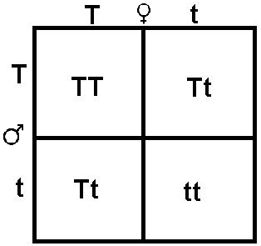

Genotypic Ratio - 1:2:1 (TT : Tt : tt)

Phenotypic Ratio – 3:1
75% = Tail 25% = No Tail

Part 5 Procedure: Making a Monster Baby: After the wedding, time to select the Genes/Alleles

- Fill in Table 5 below with the monster traits from Tables 1 and 2, as well as the traits that that you created from Tables 1.1 and 2.1.
- Flip a coin to select which alleles will be used for Mom’s and Dad’s Selected Allele that will later be used for your Baby Monster’s Genotype…heads = 1st letter of genotype, tails = 2nd letter of genotype. Write the selected allele for Mom and Dad in each box for the corresponding trait.
- Combine the alleles from Mom’s Selected Allele with Dad’s Selected Allele to determine Baby Monster’s Genotype, and record this for each trait.
- Determine Baby Monster’s Phenotype for each trait from Baby Monster’s Genotype.

Table 5: Selecting Baby Monster’s Genes
Trait | Mom’s Genotype | Dad’s Genotype | Mom’s Selected Allele | Dad’s Selected Allele | Baby Monster’s  Genotype | Baby Monster’s Phenotype

Part 6 Procedure:
- Record Baby Monster’s Genotype and Phenotype in Table 6.
- This table will be cut out and attached to your poster as well
Genotype | Phenotype

Table 6: Baby’s Traits

Part 6.5 Procedure: Law of Multiplication
- Using the Law of Multiplication determine the probability of your baby monster’s traits.
- Include this on your poster as well

Part 7 Procedure: Drawing your Monster Family
- Practice drawing your monster family (all three) on a piece of paper.
- Once you feel as though you have a good model for your monster family, draw and color them all on a poster.
- Attach the three tables (Tables 3, 4, and 6) to the front of the poster that have the genotypes and phenotypes for each member of your monster family.

What you are being graded on:

Poster with Tables 3, 4, & 6: Graded items: The tables, completion, neatness and creativity
Punnett Squares and Probability: 17 mono squares with labels, 2 dihybrid squares, and Probability of baby’s genes
The Tables 1, 1.1, 2, 2.1, and 5: Competed tables

Grading Table: Student Name _____________________________

Graded Section | Possible Points | Earned Points
Poster with Tables 3, 4, & 6 | 25
Punnett Squares and probability | 17
Tables 1, 1.1, 2, 2.1, and 5 | 8
Total Points | 50

