III. Classification
- How many known species are there? ______________
  - This is ________% of all organisms that have ever lived.
- Classification:

- What is another term for classification?
- What do you call scientists that study classification?
- Classifying organisms makes naming organisms more _____________ and _____________.
- Classifying prevents ____________ or inaccurate naming.
  - Give two examples of misnomers and explain why they aren't correct.

24. What language(s) is used for scientific naming?
- Why don't scientists around the world just use simpler, common names for organisms?
Early Taxonomists
25. Who was the first taxonomist and what two groups did he place organism in?

- How did Aristotle subdivide his two groups?

26. Who was first to use Latin for scientific naming?
- What was the problem with Ray's names?
27. What 18th century taxonomist developed the naming system still used today?
- How did Linnaeus group his organisms?
- Linnaeus is called the: "_________________________"
- Linnaeus's naming system called?
- Explain binomial nomenclature:

- What must be done to a scientific name when you are writing it?
- Give an example of a common and scientific name for an animal.
Taxonomic Groups
28. What is a taxon?

- There is a ______________ of groups that goes from the broadest grouping to the most _____________ grouping.
29. Name the 8 taxon in order from broadest to most specific.

30. Write the sentence used to help remember the 8 most important taxonomic levels.

31. Complete the following taxonomic table:
Classification for Humans
Taxonomic Level | Taxon
Domain
Kingdom
Phylum
Class
Order
Family
Genus
Species
Domains
32. Three Domains of Life
- Archaeabacteria:

- Eubacteria:

- Eukaryota:

  - Protista:

  - Fungi:

  - Plantae

  - Animalia:

Kingdom | Organization | Type of Nutrition | Examples
Protista
Fungi
Plantae
Animalia

33. What is a cladogram?

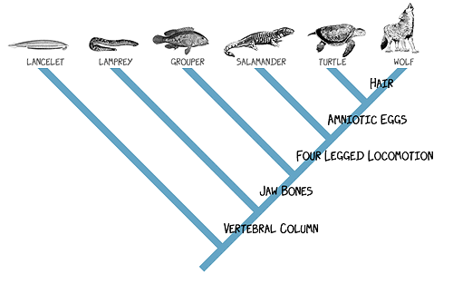
- What characteristic(s) do the grouper and lamprey share?
- What characteristic is found in all the animals EXCEPT the lancelet?

